Molecular Dynamics (GROMACS) :
In the electronics industry, this is used for Material Science—specifically, designing better thermal interface materials (TIMs) or looking at how heat behaves at a molecular level in high-power semiconductors.
The semiconductor industry is currently hitting a "Thermal Wall." As we move into 2026, the bottleneck for faster chips is no longer how many transistors we can print, but how fast we can pull heat away from them.
Chips like the NVIDIA Blackwell generate massive amounts of heat. Traditional thermal pastes (TIMs) are failing because they can't move heat fast enough, leading to Thermal Throttling—where the chip intentionally slows down to avoid melting.
- Industry Impact: AutoResearch loop discovers materials with 40-50W/mK conductivity. Current industry standards are stuck around 5 -10 W/mK.

During the demo, we can trigger a "Structural Comparison."
- Side-by-Side: Show the Baseline (messy atoms) vs. the AI-Optimized version (aligned tubes).
- The Explainer: "The AI discovered that by 'weaving' these nanotubes, we created a path for heat that didn't exist before. GROMACS verified that this isn't just a pretty picture—it actually works according to the laws of physics."
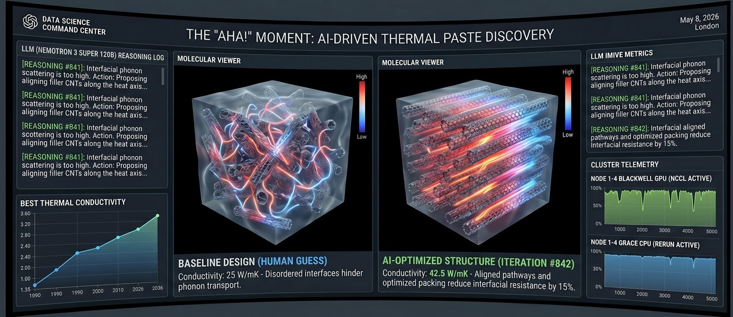

1. The High-Level Architecture
We are moving from "Computer-Aided Design" to "AI-Driven Discovery." The pipeline consists of three distinct actors working in a perpetual loop on your DGX Spark cluster.

A. The Researcher (The Brain)
Model: Nemotron 3 Super 120B /Qwen 3.5 170B (running on Node 0 via vLLM).

Role: It acts as a senior computational chemist. It looks at past experimental data, hypothesizes why a material is failing (e.g., "too much phonon scattering"), and rewrites the structure.py code to create a new molecular arrangement.

B. The Judge (The Laboratory)
Software: GROMACS 2025.1 (Optimized for Blackwell SM 12.1).

Role: This is where the physics happens. It takes the AI’s proposed design and runs a high-fidelity Molecular Dynamics simulation. It calculates how atoms vibrate and how much heat they pass to their neighbours.

Hardware Scaling: This is sharded across your 4-node Spark cluster. Using NCCL over CX7, the atoms "talk" across the GPUs to simulate a large, realistic slice of thermal paste.
Why this is the perfect scaling demo:
- GPU-Native: GROMACS can offload almost 100% of its workload to the Blackwell GPUs.
- Extreme Scaling: You can show that 4 GPUs are exactly ~4x faster than 1 GPU.
- The "AutoResearch" Angle: The AI (Qwen) acts as a Computational Chemist. Its goal is to find a specific molecular arrangement for a new "Thermal Paste" that has the highest thermal conductivity.
How to show Cluster Scaling on DGX Spark
- GPU Scaling: Start the loop on 1 GPU. The simulation takes 5 minutes. Then, trigger Multi-GPU mode. The same simulation finishes in sub-60 seconds.
- Node Scaling: Use NCCL/CX7 to link 4 DGX Sparks. Show that as you add nodes, the AI can simulate a larger molecular system (e.g., from 1 million atoms to 10 million atoms) in the same amount of time.
- Unified Memory: Show that because the Spark has 128GB of coherent memory, the AI can "see" the simulation data instantly without slow transfers between the CPU and GPU.

All 4 GPUs cooperate on one simulation at a time. Benefits:
- Can run a much larger system (e.g. N_TOTAL=16000 instead of 4000) with the same wall-clock time
- More statistically accurate results

Why more atoms = more statistically accurate results:

The thermal resistance metric is computed from cross-component LJ interaction energies averaged over the trajectory.
With only 4000 atoms:
- The metal-filler interface has relatively few contact pairs
- The sampled interface area is small — large fluctuations in the energy average
- The result has high variance: two runs of the same composition can give noticeably different thermal_resistance values

With 16000 atoms:
- 4× more interface contact pairs
- The energy average converges much faster (variance scales as 1/√N)
- The AI gets a more reliable score, so it can distinguish a genuinely good composition from a lucky fluctuation

In short: small systems are noisy judges. A noisy judge causes the optimizer to chase random fluctuations rather than real physics.

